### **Introduction:**

A date calculator is a tool or software application that helps you perform various calculations involving dates. It is often used to determine the number of days between two dates, calculate the day of the week for a specific date, add or subtract a certain number of days from a date, or find out the age difference between two individuals based on their birthdates. Date calculators are handy for a wide range of purposes, such as scheduling events, tracking deadlines, or simply managing personal and professional time-related information.

Here are some common functions that a date calculator can perform:

1. Date Difference Calculator: Calculates the number of days, weeks, months, or years between two given dates.
2. Date Addition/Subtraction: Adds or subtracts a specified number of days, weeks, months, or years from a given date.

**(2.) Objective:**

(1.) Calculate the difference between two dates.

(2.) Perform operations like addition and subtraction on dates.

**(3.) Background:**

The concept of date calculation and date calculators has a long history, dating back to the need for humans to track time, schedule events, and perform various time-related calculations.

(1.) Ancient Calendars: Early civilizations, such as the Egyptians and Babylonians, developed primitive calendars to track time and important events. These calendars were often based on astronomical observations and lunar or solar cycles. Ancient methods of date calculation were manual and involved counting days, moons, or years.

(2.) Mechanical Calculators: With the advent of technology, mechanical calculators and slide rules were developed in the 17th and 18th centuries to assist with various mathematical calculations, including date-related calculations.

(3.) Digital Age: The digital age brought about electronic calculators, personal computers, and software applications that made date calculation and management much more accessible and efficient. Date calculators became a standard feature in spreadsheet software like Microsoft Excel

(4.) Online Date Calculators: With the growth of the internet, online date calculators became widely available to users around the world. These calculators are accessible through web browsers and provide a convenient way to perform date-related calculations.

**(4.) Hardware and Software Requirements:**

This simple python program can run on any modern computer.

It also requires python installed on the system along with modules like tkinter and

datetime.

**(5.) Coding:**

The program is coded in python using tkinter for GUI.

The algorithm to find difference between two dates goes like this:

1. Take the input from the user and store it in a variable of StringVar() datatype.

2. Using the datetime module, convert the string into date of format dd/mm/yyyy.

3. Subtract the second date from the first date using timedelta() and get the answer in

days.

**(6.) Output Screenshot:**

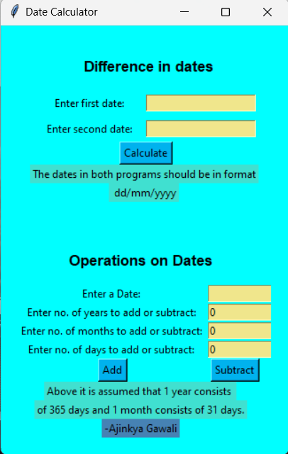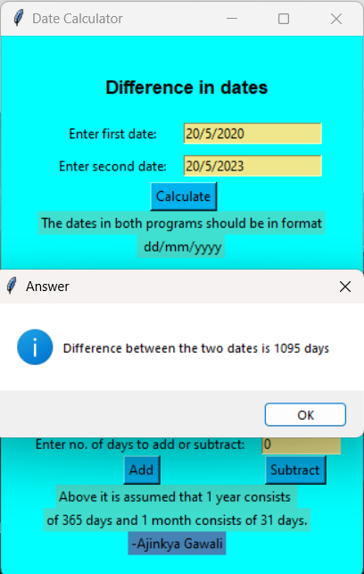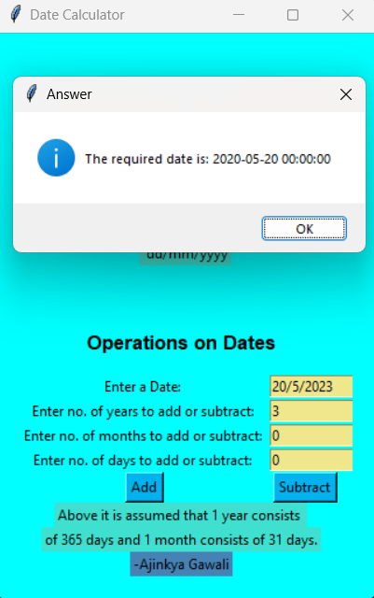

**(7.) Future Scope:**

The future scope of date calculators is likely to continue evolving to meet the changing needs of individuals and organizations. Here are some potential directions and developments for date calculators in the future:

(1.) Enhanced Integration: Date calculators will likely become even more integrated into various software applications, including calendar apps, project management tools, scheduling software, and personal assistants like virtual chatbots and voice-activated assistants. This integration will make it easier for users to perform date-related calculations seamlessly within their existing workflows.

(2.) Machine Learning and AI: Artificial intelligence (AI) and machine learning can be applied to date calculations to predict future dates, optimize schedules, and suggest optimal times for events and activities based on historical data and user preferences.

(3.) Smart Reminders and Alerts: Date calculators may evolve to provide more intelligent reminders and alerts for important dates, deadlines, and events. They could leverage AI to consider factors like traffic conditions, weather, and other external factors when sending notifications.

Overall, the future scope of date calculators is closely tied to advancements in technology, user needs, and the evolving ways in which people and organizations manage time-related information. As technology continues to advance, date calculators will play a critical role in helping us manage our schedules, plan events, and make the most of our time.

**(8.) CONCLUSION:**

In conclusion, date calculators have a rich history rooted in the human need to track time and perform date-related calculations. From ancient calendars to modern digital tools, date calculators have evolved significantly. Their future scope is promising, with ongoing advancements in technology and user needs driving their development. We can expect date calculators to become even more integrated, personalized, and intelligent, offering enhanced features such as AI-driven predictions, multi-calendar support, and better privacy and security measures. These tools will continue to play a vital role in helping individuals and organizations manage time-related information effectively, making scheduling, planning, and tracking important events more convenient and efficient in the digital age.

**(9.) REFERENCES AND BIBLIOGRAPHY:**

1. <https://www.geeksforgeeks.org/find-number-of-days-between-two-given-dates/>

2. <https://docs.python.org/3/library/tkinter.html>

3. <http://www.sunshine2k.de/articles/coding/datediffindays/calcdiffofdatesindates.html>